**Progress Report**

**- Increment 1 -**

**Group #17**

# Team Members

# Aamir Baloch, amb21w, ABaloch1

# Blake Barth, bmb22b, Blake1720

# Jacob Copham, jlc21b, jcopham

# Joshua Krug, jak21i, AusarTheVil3

* Ethan Lin, el21v, WindowsSystemAdmin

1. **Project Title and Description**

Gather. Arm. Manage. Endure. (G.A.M.E.)

We are making a single-player video game that is a mixture of tower defense, platforming, puzzles, and resource managing. We are incorporating physics-based movement and randomly seeded resources to find as you explore. We are making waves of enemies to defend against, science-based puzzles to solve which will unlock unique upgrades, and we have written an intriguing, mysterious story. We are making the game to have a cyberspace-theme, with music and designs fitting that aesthetic.

1. **Accomplishments and overall project status during this increment**

During this increment, we did the work of setting up the GitHub. This included brainstorming issues for the issue tracker, assigning areas of specialization for each person, and creating initial files and branches. We created branches for each area, including the story, level design, player design and enemy design. Overall, this is a good starting point for our project with a common basis and each branch being able to be worked on individually. Compared to the initial scope we still feel that we accomplished what we wanted for this increment and are on track to complete the rest of the functionality.

1. **Challenges, changes in the plan and scope of the project and things that went wrong during this increment**

Some challenges we had were getting to know how to use Phaser.js, managing the GitHub, and some communication challenges. To resolve the challenge, we created a Discord channel where we shared resources on how to use Phaser and planned our next meetings. Managing the GitHub correctly was simply a matter of time, as each person in the group needed to get experience committing, adding issues, and merging branches.

1. **Team Member Contribution for this increment**
   1. **The progress report:**

Joshua Krug – Wrote section 2

Jacob Copham – Wrote section 3

Ethan Lin - Wrote section 4

Aamir Baloch – Wrote section 6, 7

Everyone – Sections 1, 5

* 1. **The requirements and design document:**

Joshua Krug – Wrote sections 1, 2, 4, 5, 7

Ethan Lin – Wrote section 6

Jacob Copham – Wrote section 3

* 1. **The implementation and testing document:**

Jacob Copham – Wrote sections 1, 4, 5

Aamir Baloch- Wrote section 3

Blake Barth – Wrote section 2

* 1. **The source code:**

Joshua Krug – Wrote story, initial commits of level.js, player.js, and index.html

Jacob Copham – Creator of resources.txt and resources.js, began formulating resources set up

Ethan Lin – Coded the title screen, and the settings.

Aamir Baloch- Organization of issue tracker, beginning character design.

Blake Barth – Wrote the enemy class, changed index.html to accompany it, and modified the level class to create the current demo setup.

* 1. **The video or presentation:**

Aamir Baloch & Blake Barth – Collaborated and recorded video together.

1. **Plans for the next increment**

We want to get better at scheduling times to meet and work as a group. Due to all of our busy schedules, we are planning on smaller group meetings going forward, instead of trying to coordinate a big group meetup to discuss the project. The team has agreed upon working on the project in a pair programming setting going forward. We have been trying our best to utilize the branches on GitHub and tackle one issue at a time. We will continue to add more issues as we continue working on the project. Our group plans to have the beginnings of a working game by the time of the next increment and wish to have the following complete:

* Complete the game’s visual aspects.
* Have the combat system functioning at its most basic level.
* Ensure the inventory management system is operational.
* Smoothly integrate the beginning story elements.
* Enable users to execute game setting changes effectively.

1. **Stakeholder Communication**

Dear Stakeholders,

We are pleased to report that group 17 is making excellent progress on G.A.M.E and would like to provide a progress update. We have officially moved into the development phase after officially completing the initial learning phase. Each team member has gained a solid understanding of the necessary software and environment, setting a strong foundation for the coding and design work now underway. The team has encountered a few issues with the development process and even with the progress being made. Coordination amongst the team, specifically in scheduling and adequate time commitment has proven more difficult than anticipated. Despite our best efforts, it has become apparent that managing multiple responsibilities outside of the project has affected our projected momentum. To mitigate this, we are implementing better strategies of accountability and peer coding sessions.

As stated previously, we are slightly our anticipated timeline. By this point of project development, we were aiming towards some sort of visual framework for our game to have a good foundational point. Our focus now is on refining our workflow and ensuring that tasks are aligned with both immediate deliverables and the overall project vision.

Moving forward, we are committed to ensuring the team collaboration becomes more structured and consistent. For our next checkpoint, our goal is to achieve the following milestones:

* Complete the game’s visual aspects.
* Have the combat system functioning at its most basic level.
* Ensure the inventory management system is operational.
* Smoothly integrate the beginning story elements.
* Enable users to execute game setting changes effectively.

We appreciate your continued trust and support and will keep you informed as we progress toward these key goals.

Best regards,

Project G.A.M.E

1. **Link to video**

[*https://youtu.be/irBSWZUsGVY*](https://youtu.be/irBSWZUsGVY)

[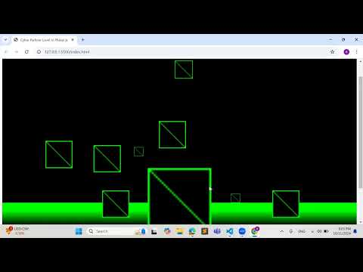](https://youtu.be/irBSWZUsGVY)